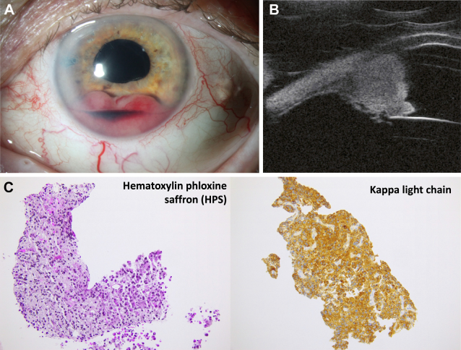

A 74-year-old woman presented with painless blurred vision in her left eye. Visualacuity was 20/40 with intraocular pressure of 27 mmHg. Examination revealed a hemorrhagic whitish iris mass (A, B). Iris biopsydemonstrated a monoclonal plasma cell infiltration, with positive immunoreactivity for kappa light chains (C). Based on the provided images and clinical description please make an ophthalmic diagnosis for this patient. And output the diagnostic conclusions only.

**Ocular Plasmacytoma**